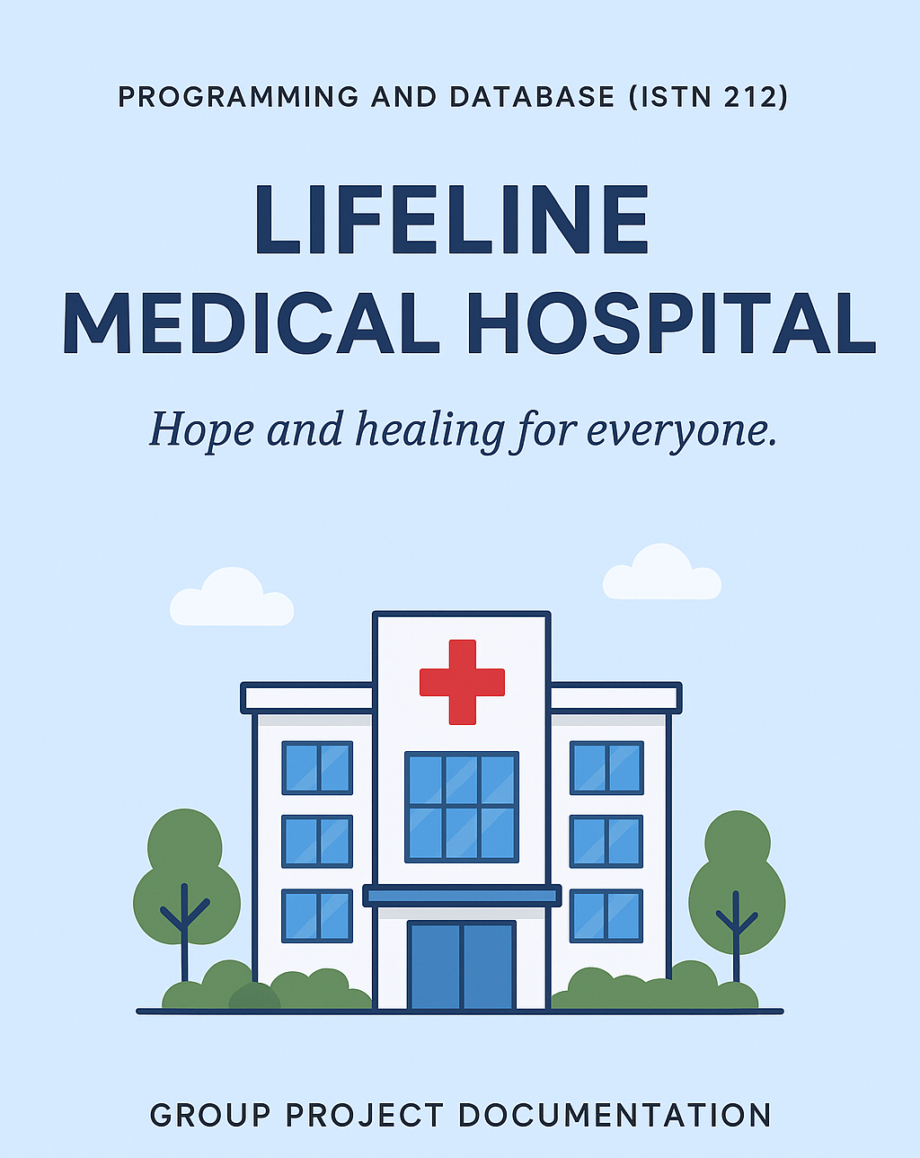
Contents

Introduction…………………………………………………………………………………………………….4
Problem…………………………………………………………………………………………………………5
Admin’s Homepage………………………………………………………………………………………….6
Navigation Buttons: 7
Patient Management 8
Department Management 8
Dashboard Insights 9
Appointment Management 9
Book Appointment button: 9
DOCTOR’S HOMEPAGE 11
Conclusion………………………………………………………………………………………………12

PROGRAMMING AND DATABASE (ISTN 212)
GROUP PROJECT DOCUMENTATION
DATE: 06 OCTOBER 2025
GROUP MEMBERS:
- ASANDA JELE (223109140)
- MINENHLE NDLOVU (223007478)
- NOMCEBO ZULU (224088934)
- BONGUMUSA GUMEDE (223034963)
- HALALISANI NGCOBO (224115052)
- LUNGISANI MNYANDU (223145384)

LOGIN DETAILS: LUNGISANI MNYANDU
USERNAME: ist2ib
PASSWORD: 563feb

LIFELINE MEDICAL HOSPITAL

Introduction
This document provides the full project documentation for a Windows Forms–based application developed using C# on the Visual Studio 2022 .NET Framework. The application has been designed for Lifeline Medical Hospital, a state-owned healthcare facility, to manage patient appointments and hospital operations more efficiently. The system aims to replace the traditional walk-in method that often leads to long queues and overcrowding with a modern, automated booking process. The application consists of multiple interconnected forms, each serving a distinct purpose in the hospital workflow. From secure user authentication and administrative management to appointment scheduling and medical record handling, the system simulates real-world hospital procedures in a structured and user-friendly way. The application enables users to register patients, book and manage appointments, validate patient information, and view or update medical records. This design ensures that patients are attended to promptly and efficiently, while also allowing doctors and administrators to manage operations easily.

Problem
The Lifeline Hospital is a state-owned medical facility which offers diverse medical services and specialized treatment, including cardiology, dermatology, neurology, paediatrics, orthopaedics, general and a variety of other medical fields. Being a community-based hospital, it serves a high population of clients every day, most of whom rely on the affordable and accessible services. Nevertheless, despite the vast scope of its services, Lifeline Hospital is experiencing the same problem, long queues and lengthy waiting periods. Patients are forced to spend several hours waiting to be served not because the medical personnel are busy, but rather because there is no formal and effective system of appointment booking. The old method of walking-in leads to overcrowding, patient dissatisfaction and even lost or delayed appointments.

Solution
To correct these problems, the project proposes the creation of appropriate hospital booking application system. This online system will enable patients to easily make appointments online, choose the specialty they need (cardiology, dermatology, neurology, paediatrics, orthopaedics, and so on), and have a confirmation that they are coming to the hospital. Not only will the system reduce unnecessary waiting time, but it will also make the processes within the hospital to be smoother, better schedules of the doctors will be managed, resources will be allocated efficiently, and patient flow will be optimized. By so doing, the project will result in improved patient experience, quick access to services, reduces waiting times, improves the accuracy of patient records bays, and an overall contribution to better healthcare delivery at Lifeline Hospital.
.
How the system works:
- Progress Bar
When the lifeline hospital is started, therefore, a progress bar appears to signal the system start. a progress bar appears with a welcome to Lifeline hospital text and a circular loading icon and a please wait text. The screen will stay until the system is clear and available to be interacted with by the user.
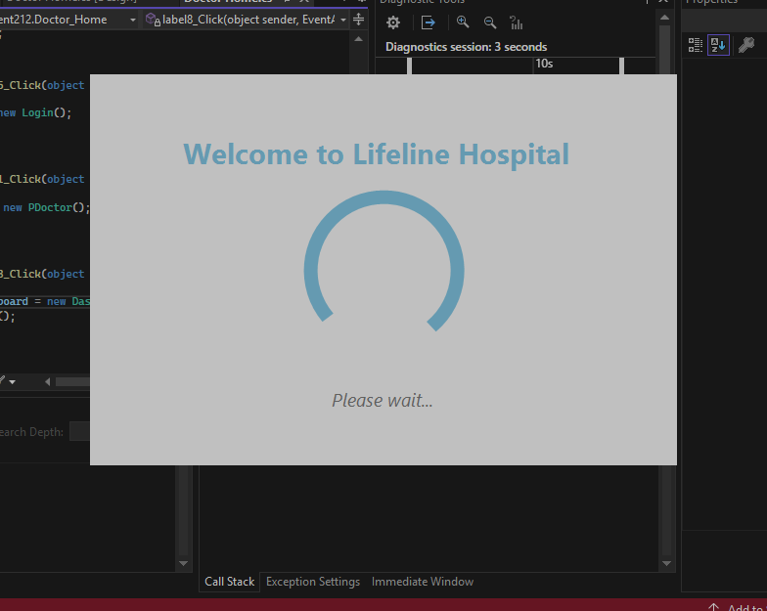
Figure 1: Progress Bar

Form 1: Login Page
The purpose of this form is to authenticate users and grant access to the system.
Interface components
- Username: input field for users’ username.
- Password: Input user’ username
For logging in the system forces the user to put a strong password including uppercase, lowercase, digits, special characters and the length of the password should be greater than 8. If this criterion is not met, the label will display to inform the error.
Action buttons:
- Login: Button to submit credentials for authentication for Admin/Doctors who are already existing in the system. If the user logs in successfully a message box will appear “Login successfully” and user is able to show or hide his/her password. If Admin is logged in it will take him/her to their home page and if the doctor logs in it will also them to their separate home page.

- Clear: Button to clear entered credentials

- Existing profile inquiry: question asking about the existing user, with 2 option “yes or no”. If the user selects no, the sign-up button provides an option to create a new profile.

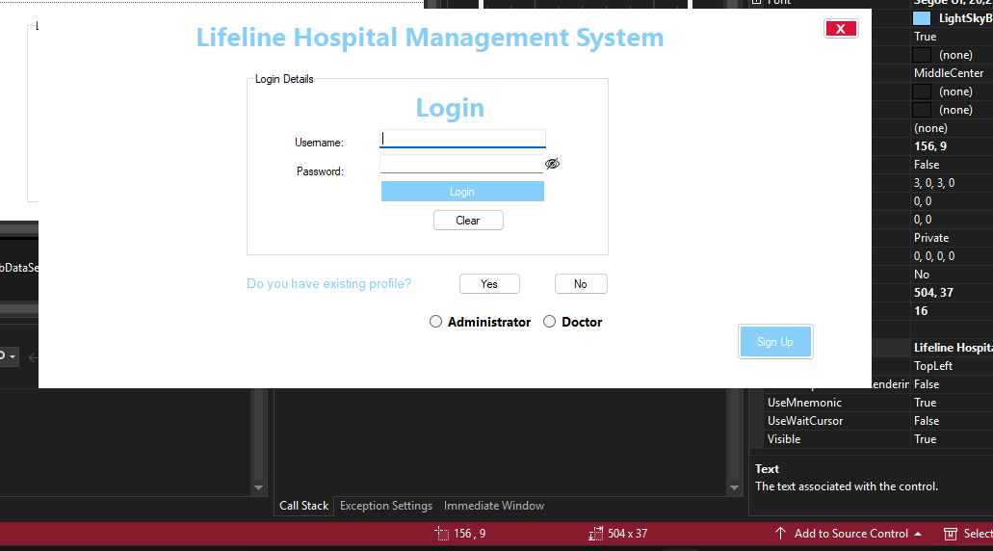
Figure 2: Login Page

Admin Homepage
Admin Homepage serves as a primary interface for administrative tasks, providing quick access to key features and insights. The page is divided into several sections, each catering to a specific aspect of administration.

Navigation Buttons:
The Admin Home Page includes the following navigation buttons:
- Patients: Redirects to the Patients homepage, where administrators can manage patient information.
- Dashboard: Takes you to the Dashboard page, which provides insights and analytics on key metrics.
- Doctors: Redirects to the Doctors page where administrators manage doctor records .
- Appointments: Redirects to the Appointments homepage, where administrators can manage appointments and bookings.
- Department: Takes you to the Department homepage, where administrators can manage departmental information.
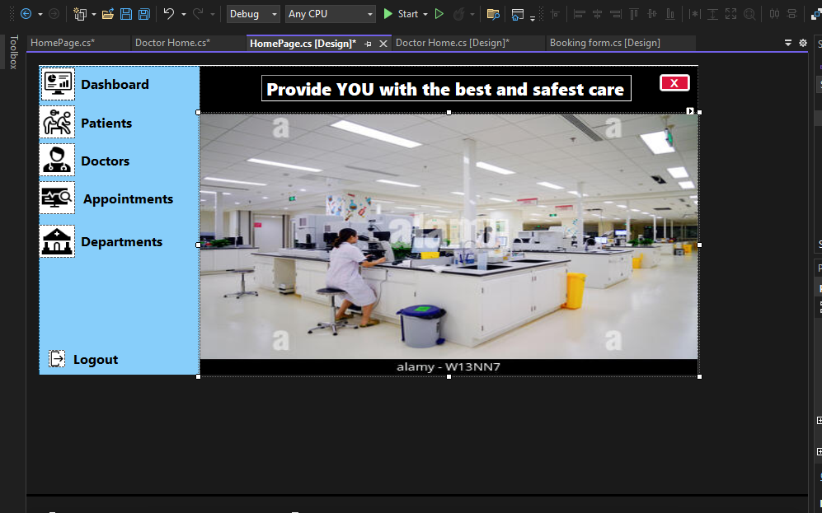
Figure 3: Admin's Home Page

Patient Management
The Patients section allows administrators to:
- Add new patients: Create new patient profiles with relevant information.
- Delete patient information: Remove patient records from the system.
- Update patient information: Modify existing patient details.

Department Management
The Department section allows administrators to:
- Add new departments: Create new department profiles with relevant information.
- Delete department information: Remove department records from the system.
- Update department information: Modify existing department details.

Dashboard Insights
The Dashboard provides valuable insights into key metrics, including:
- Total patients: Displays the total number of patients in the system.
- Total doctors: Displays the total number of doctors in the system.
- Appointments made each day: Displays the number of appointments scheduled for each day.

Appointment Management
The Appointments section allows administrators to:
- Add new appointments: Create new appointments with patients and doctors.
- Delete appointments: Remove existing appointments from the system.
- Update appointments: Modify existing appointment details.
- Book an appointment: Schedule a new appointment for a patient with a doctor.

Book Appointment button:
When the book appointment button is clicked, the system is directed to the bookings form. The primary goal of this form is to allow the admin to enter personal details of patients, capture appointments related data and manage appointment booking.
Personal Details Interface:
- Full name textbox: designed to capture the complete, legal name of the person booking the appointment.
- ID Number textbox: The ID Number textbox is a very vital part of the Appointment Form; this is meant to ensure that users are correctly identified. Its main use is to authenticate the entered ID number and automatically retrieve important personal information. Once the user moves out of the textbox (by moving the cursor or clicking the rest of the areas), a system validation and data extraction procedure occurs.
Functionality Validation: The system verifies the format and length of the entered ID number (e.g., the number must contain 13 numerical characters in South African format of ID). It ensures the validity of the date information in the ID number and satisfies any checksum or logical validation requirements in place. Error Handling In the case of invalid ID number, the system returns an error message as soon as the user is out of the textbox. The error message will alert the user to correct the input before proceeding (“ID number is not valid”). The system will not allow any more dependent field to be generated until the ID number is valid. Data Generation Upon entering a valid ID number, the system automatically pulls off and auto-fills the following fields: Data of Birth: Passed onto the first six digits of ID number (DDMMYY). Gender: Objective based on the sequence code in the ID number (usually digits 7-10, with results under 5000 signifying female and results over 5000 signifying male). Age: Computed process-on-the-fly using the computed Date of Birth and the current system date.
- Province Combo Box: Given nine provinces in the combo box the user must select only one province of where he/she resides.
- City Combo Box: The user also selects the respective city in their province
- Date time picker: Allows for user to select the date and time when appointment will take place.
- Capture button: Display the summary of the appointment details in the list box.
- Print Button: Print appointment details that are already displayed in the listbox

DOCTOR’S HOMEPAGE: This page serves as a portal for doctors to manage and access patient’s medical records.
Navigation buttons:
Medical record: Access patients medical records
Doctor: Redirect doctors to their homepage where they can modify information.
Medical management:
- View medical records: Doctors can view and read medical records of their patients.
- Insert: Doctors can add information to a patient's medical record when required.
- Delete information: Doctors can erase information on the medical record of the patient
- Update Information: Doctors may update existing information within a patient's medical record.
Doctor Management:
- View doctor records: Doctors can view and read their records.
- Insert: Doctors can add their information when required.
- Delete information: Doctors can erase their information when required.
- Update Information: Doctors may update existing information within their records.
- Search by DoctorName textbox:
“SELECT DoctorID, DoctorName, Specialization, EmailAddress, PhoneNo
FROM DOCTOR
WHERE ( DoctorName LIKE @name + '%')”
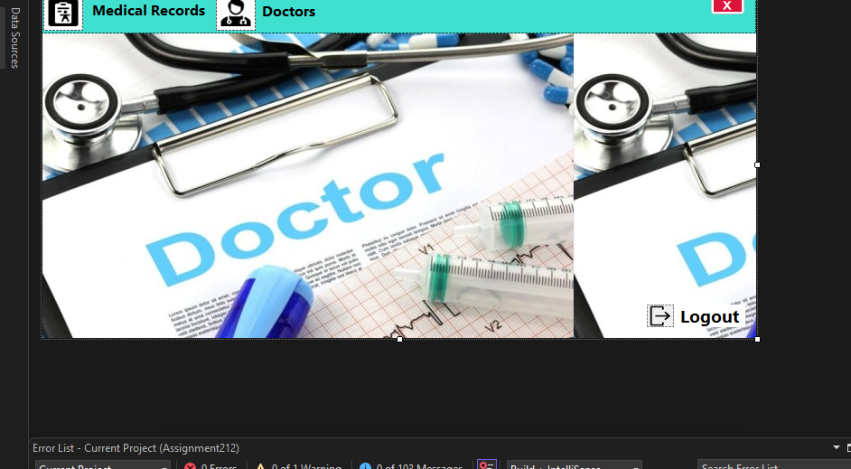
Figure 4: Doctors Page

Conclusion
The Lifeline Medical Hospital Booking System enhances efficiency, minimizes patient waiting time, and improves overall healthcare management. It provides a robust platform for both administrators and doctors to manage appointments and patient data effectively, ensuring a smoother hospital operation and a better patient experience. The professional interface design, combined with additional features like animated splash screens and saving animations, demonstrates careful attention to both technical functionality and user experience. This project confidently represents a system that clients would trust for real-world clinic operations.

